Document Objective
This document explains how to set up an IMAP or POP email address on android devices.

Document Summary
Adding your email address should take up to 5 minutes.

Document Detail
Navigate to your phone’s Settings
Android devices can vary, the following gif shows how to navigate on a Samsung Galaxy A12 however the menus on other android devices are very similar. (e.g. ‘Passwords and accounts’ could replace ‘accounts’)
- Navigate to “Accounts”
- Navigate to “Manage Accounts”
- Navigate to “Add Account”
- Select “Personal (IMAP)”

Please see the below animated picture showing the instructions above. The animated picture starts here: 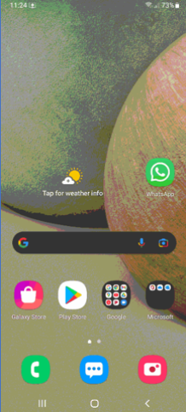
You can pause the picture by clicking on the pause button in the centre when you hover your mouse over it, or in the bottom left if you have clicked anywhere else in the picture.

Next we set up the account information.
- Enter your email address
- Select Set up manually/Manual Setup
- Select the option relevant to you (IMAP or POP3)
- Enter your password
- Change the incoming server to the server you were given, e.g. mail10.extendcp.co.uk
- Select Next
- Change the outgoing server to the server you were given, e.g. mail10.extendcp.co.uk
- Select Next
- Select Next again on the new screen.
- Here you may change your account name and your display name
  - Changing the account name will only affect what it looks like in your mail application on your phone
  - Changing your display name will display this value when people receive messages from you
- Select Next
Please see the below animated picture showing the instructions above. The animated picture starts here:
You can pause the picture by clicking on the pause button in the centre when you hover your mouse over it, or in the bottom left if you have clicked anywhere else in the picture.

It should then finish setting up your email account making it available in your mail app.

